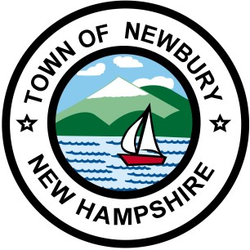

Newbury Code Enforcement Office - Letter of Agency
Property Owners Name: ____________________________________________
Property Owners Mailing Address: ____________________________________________
Property Owners Phone: ____________________________________________
Property Owners Cell #: ____________________________________________
Property Owners Email Address: ____________________________________________
Construction Address: ____________________________________________
Map and Lot Number ____________________________________________
Contractor/Agent Name ____________________________________________
Agent Address: ____________________________________________
Agent Phone Number: ____________________________________________
Agent Cellphone Number: ____________________________________________
Agent Email Address: ____________________________________________

I, the undersigned, hereby authorize _____________________________________ to act on my behalf as my agent in all matters related to the repairs, remodeling, construction and/or other related activities that occur at the above construction address.
Property Owners Signature: ______________________________________________
Date: _______________________________________________

3/20/2020

